Ex. No. : 08 - A Date :
Register No. : 221701007 Name : AMRITHA A

Send SMS
Aim
Develop an application to send SMS.

Procedure:

Step 1 : File → New Project
Provide the application name (e.g.,"SMS") and click “Next”.
Step 2 : Select the target Android devices
Select the minimum SDK to run the application. Click “Next”.
Step 3 : Choose the activity for the application
By default, choose “Blank Activity”. Click “Next”.
Step 4 : Enter activity name and click “Finish”.
Step 5 : Edit the program
Add SMS permissions (SEND_SMS) in the manifest file.
Use SMSMANAGER in MainActivity.kt to send messages from the app to a . provided phone number
Step 6 : Run the application
Two ways to run the application:
1. Running through emulator (with Sim Card Configured )
2. Running through mobile device

AndroidManifest.xml

<?xml version="1.0" encoding="utf-8"?>
<manifest xmlns:android="http://schemas.android.com/apk/res/android"
package="com.example.sms">

<!-- Required permission for sending SMS -->
<uses-permission android:name="android.permission.SEND_SMS" />

<!-- Declare that the app uses telephony features but doesn't require them -->
<uses-feature
android:name="android.hardware.telephony"
android:required="false" />

<application
android:allowBackup="true"
android:icon="@mipmap/ic_launcher"
android:label="@string/app_name"
android:roundIcon="@mipmap/ic_launcher_round"
android:supportsRtl="true"
android:theme="@style/Theme.SMS">
<activity
android:name=".MainActivity"
android:exported="true">
<intent-filter>
<action android:name="android.intent.action.MAIN" />
<category android:name="android.intent.category.LAUNCHER" />
</intent-filter>
</activity>
</application>

</manifest>

Activity_main.xml

<?xml version="1.0" encoding="utf-8"?>
<androidx.constraintlayout.widget.ConstraintLayout xmlns:android="http://schemas.android.com/apk/res/android"
xmlns:app="http://schemas.android.com/apk/res-auto"
xmlns:tools="http://schemas.android.com/tools"
android:layout_width="match_parent"
android:layout_height="match_parent"
android:background="@color/white"
tools:context=".MainActivity">

<TextView
android:id="@+id/titleTextView"
android:layout_width="match_parent"
android:layout_height="wrap_content"
android:background="@color/purple_500"
android:padding="16dp"
android:text="Send SMS"
android:textColor="@color/white"
android:textSize="20sp"
android:textStyle="bold"
app:layout_constraintTop_toTopOf="parent" />

<EditText
android:id="@+id/phoneNumberEditText"
android:layout_width="match_parent"
android:layout_height="wrap_content"
android:layout_marginStart="16dp"
android:layout_marginTop="16dp"
android:layout_marginEnd="16dp"
android:background="@drawable/edit_text_background"
android:hint="Enter the phone number...!"
android:inputType="phone"
android:padding="12dp"
android:textSize="16sp"
app:layout_constraintTop_toBottomOf="@id/titleTextView" />

<EditText
android:id="@+id/messageEditText"
android:layout_width="match_parent"
android:layout_height="wrap_content"
android:layout_marginStart="16dp"
android:layout_marginTop="16dp"
android:layout_marginEnd="16dp"
android:background="@drawable/edit_text_background"
android:hint="Enter the message...!"
android:inputType="textMultiLine"
android:minLines="3"
android:padding="12dp"
android:textSize="16sp"
app:layout_constraintTop_toBottomOf="@id/phoneNumberEditText" />

<Button
android:id="@+id/sendButton"
android:layout_width="match_parent"
android:layout_height="wrap_content"
android:layout_marginStart="16dp"
android:layout_marginTop="16dp"
android:layout_marginEnd="16dp"
android:background="@drawable/button_background"
android:padding="12dp"
android:text="Send"
android:textColor="@color/white"
android:textSize="16sp"
app:layout_constraintTop_toBottomOf="@id/messageEditText" />

</androidx.constraintlayout.widget.ConstraintLayout>
MainActivity.kt

package com.example.sms

import android.Manifest
import android.content.pm.PackageManager
import android.os.Build
import android.os.Bundle
import android.telephony.SmsManager
import android.widget.Button
import android.widget.EditText
import android.widget.Toast
import androidx.appcompat.app.AlertDialog
import android.appcompat.app.AppCompatActivity
import android.core.app.ActivityCompat
import androidx.core.content.ContextCompat

class MainActivity : AppCompatActivity() {
private lateinit var phoneNumberEditText: EditText
private lateinit var messageEditText: EditText
private lateinit var sendButton: Button

private val SMS_PERMISSION_CODE = 100

override fun onCreate(savedInstanceState: Bundle?) {
super.onCreate(savedInstanceState)
setContentView(R.layout.activity_main)

// Initialize views
phoneNumberEditText = findViewById(R.id.phoneNumberEditText)
messageEditText = findViewById(R.id.messageEditText)
sendButton = findViewById(R.id.sendButton)

// Set click listener for the send button
sendButton.setOnClickListener {
if (checkSmsPermission()) {
sendSMS()
} else {
requestSmsPermission()
}
}
}

private fun checkSmsPermission(): Boolean {
return ContextCompat.checkSelfPermission(
this,
Manifest.permission.SEND_SMS
) == PackageManager.PERMISSION_GRANTED
}

private fun requestSmsPermission() {
if (ActivityCompat.shouldShowRequestPermissionRationale(
this,
Manifest.permission.SEND_SMS
)
) {
// Show custom dialog explaining why we need this permission
AlertDialog.Builder(this)
.setTitle("Permission needed")
.setMessage("Allow Send SMS to send and view SMS messages?")
.setPositiveButton("ALLOW") { _, _ ->
ActivityCompat.requestPermissions(
this,
arrayOf(Manifest.permission.SEND_SMS),
SMS_PERMISSION_CODE
)
}
.setNegativeButton("DENY") { dialog, _ ->
dialog.dismiss()
}
.create()
.show()
} else {
// Request permission directly
ActivityCompat.requestPermissions(
this,
arrayOf(Manifest.permission.SEND_SMS),
SMS_PERMISSION_CODE
)
}
}

override fun onRequestPermissionsResult(
requestCode: Int,
permissions: Array<out String>,
grantResults: IntArray
) {
super.onRequestPermissionsResult(requestCode, permissions, grantResults)
if (requestCode == SMS_PERMISSION_CODE) {
if (grantResults.isNotEmpty() && grantResults[0] == PackageManager.PERMISSION_GRANTED) {
// Permission granted, send the SMS
sendSMS()
} else {
// Permission denied
Toast.makeText(
this,
"SMS permission denied. Cannot send messages.",
Toast.LENGTH_SHORT
).show()
}
}
}

private fun sendSMS() {
val phoneNumber = phoneNumberEditText.text.toString().trim()
val message = messageEditText.text.toString().trim()

if (phoneNumber.isEmpty() || message.isEmpty()) {
Toast.makeText(this, "Please enter both phone number and message", Toast.LENGTH_SHORT).show()
return
}

try {
val smsManager = if (Build.VERSION.SDK_INT >= Build.VERSION_CODES.S) {
this.getSystemService(SmsManager::class.java)
} else {
@Suppress("DEPRECATION")
SmsManager.getDefault()
}

smsManager.sendTextMessage(phoneNumber, null, message, null, null)
Toast.makeText(this, "Message Sent", Toast.LENGTH_SHORT).show()

// Clear fields after sending
messageEditText.text.clear()
} catch (e: Exception) {
Toast.makeText(this, "Failed to send SMS: ${e.message}", Toast.LENGTH_SHORT).show()
e.printStackTrace()
}
}
}

Output

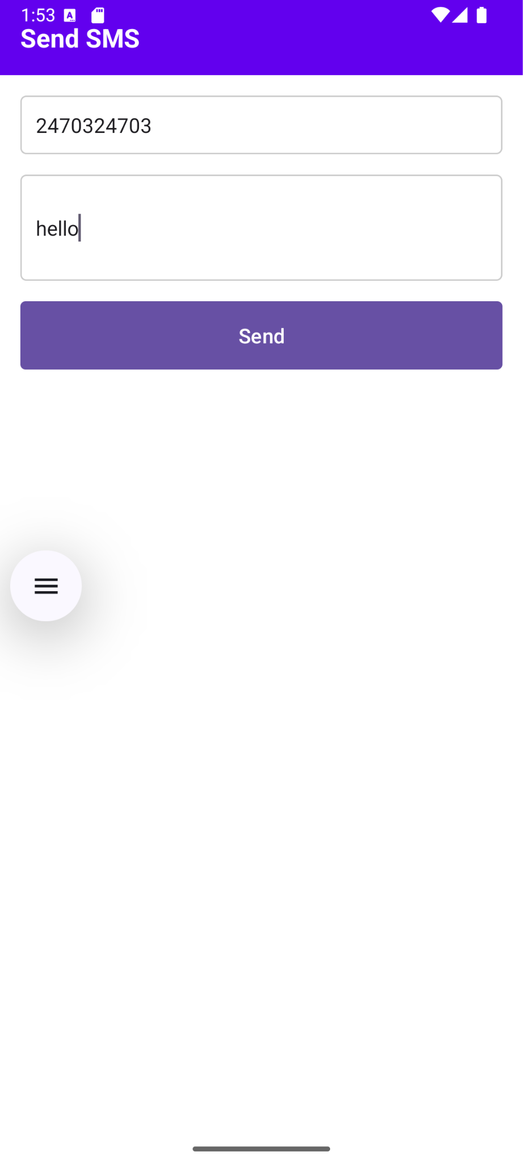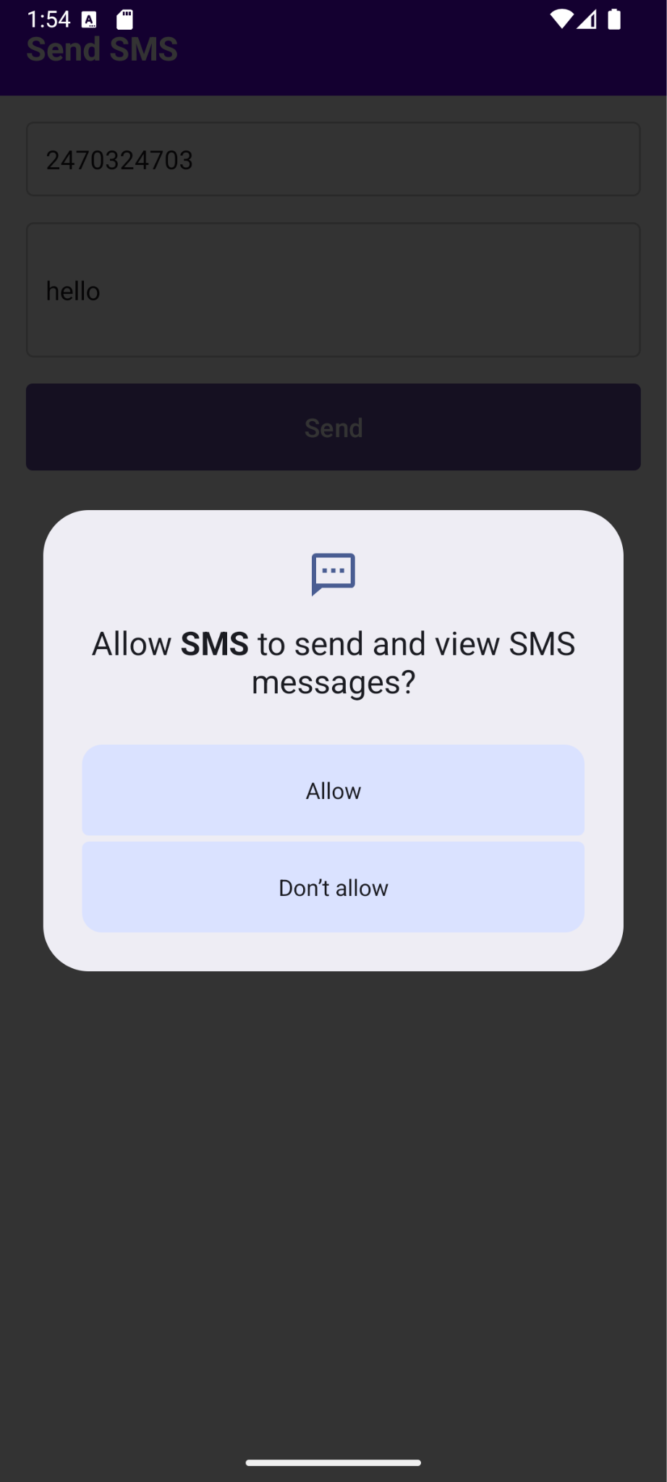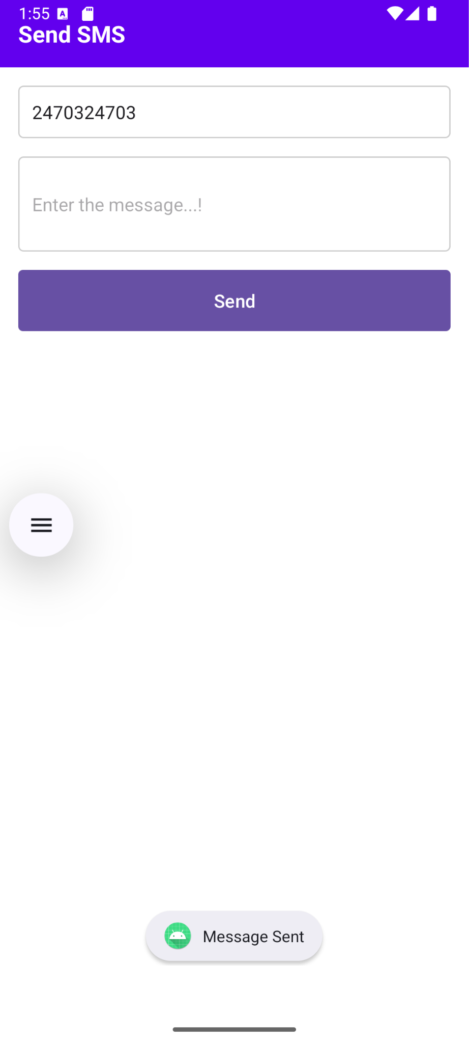

Result:
The SMS application successfully sends text messages to specified phone numbers using Kotlin code on a mobile device with SMS permission granted.

